Asia-China-Coin-Round- FD-371-R 0

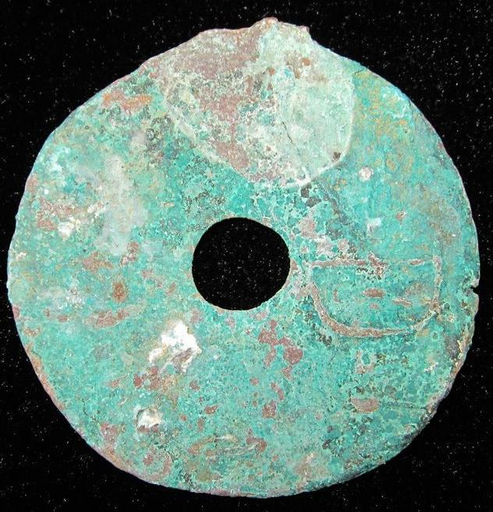

古圜钱,"GU"Coin. Obverse: "古" "JI". JI was a city in the state of Yan. This is a rarity of the highest order, and the only reference is Fisher's Ding where it is listed as "price not determined".. 4.1 cm. / 1.61 in. FD-371, SH---, H---, S---.

We can only guess at a value for something this rare, but probably somewhere in the $7500.00 range

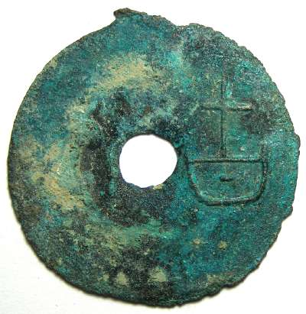

Another example Average (1 specimen) 41.2 mm, 10.05 grams

